A

PROJECT REPORT

ON

**VR Horror Game**

Submitted in partial fulfillment of the requirements of the degree of

**Bachelor of Engineering**

**In**

**Information Technology**

by

Ritvik Babre - 5

Hitesh Behera - 6

Shruti Sabbani – 50

Swapnil Yadav - 67

Supervisor(s):

Asst. Prof. Punam Bagul



**Department of Information Technology**

K.C. College of Engineering and Management Studies And

Research, Thane (E)

University of Mumbai

2023-24

**CERTIFICATE**

This is to certify that the project entitled “ **VR Horror Game** ” is a bonafide work of “**Ritvik Babre - 5 , Hitesh Behera - 6 , Shruti Sabbani – 50 , Swapnil Yadav - 67**”submitted to the University of Mumbai in partial fulfillment of the requirement for the award of the degree of **“Bachelor of Engineering”** in **“Information Technology”**.

Asst. Prof. Punam Bagul Asst. Prof. Aarti Abhyankar

Supervisor/Guide Co Supervisor/Guide



Prof. Amarja Adgaonkar Dr. Vilas Nitnaware

Head of Department Principal

**Project Report Approval for B.E.**

This project report entitled ***VR Horror Game*** by ***Ritvik Babre - 5, Hitesh Behera - 6, Shruti Sabbani - 50, Swapnil Yadav - 67*** is approved for the degree of Bachelor of Engineering in **Information Technology.**

Examiners

1.---------------------------------------------

2.---------------------------------------------

Date:

Place:

**DECLARATION**

We declare that this written submission represents our ideas in our own words and where others' ideas or words have been included, we have adequately cited and referenced the original sources. We also declare that we have adhered to all principles of academic honesty and integrity and have not misrepresented or fabricated or falsified any idea/data/fact/source in my submission. We understand that any violation of the above will be cause for disciplinary action by the Institute and can also evoke penal action from the sources which have thus not been properly cited or from whom proper permission has not been taken when needed.

_________________________

Ritvik Babre - 5

Hitesh Behera - 6

Shruti Sabbani - 50

Swapnil Yadav - 67

Date:

**ACKNOWLEDGEMENT**

We would like to express special thanks of gratitude to our guide **Asst. Prof. Punam Bagul** who gave us the golden opportunity to do this wonderful project on the topic of VR Horror Game, which also helped us in doing a lot of research and we came to know about so many new things. We are very grateful to our Head of the Department **Prof. Amarja Adgaonkar** for extending her help directly and indirectly through various channels in our project work**.** We would also like to thank I/C Principal **Dr. Vilas N Nitnaware** for providing us the opportunity to implement our project. We are really thankful to them. Finally we would also like to thank our parents and friends who helped us a lot in finalizing this project within the limited time frame.

Thanking You.

**TABLE OF CONTENT**

**Sr.No. Topic Page No.**

**Certificate ….………….……………………………………. i**

**Approval Sheet …..…………………………………………. ii**

**Declaration   ………………………………………………….. iii**

**Acknowledgement ………………………………………..… v**

**List of Figures ...……………………………………………… vii**

**List of Tables .………………………………………………… viii**

**Abstract ...…………………………………………………… ix**

1. **Introduction ………………………………………………………… 10**
2. **Review of Literature ………………………………………………… 11**
3. **Proposed Work 13**

3.1. Requirement Analysis ………………………………

* + 1. Scope ……………………………… 13

3.1.2 Feasibility Study ……………………… 14

3.1.3 Hardware & Software Requirement ……….. 15

3.2 Problem Statement …………………………………………… 16

3.3 Project Design …………………………………………………. 17

3.4 Methodology…………………………………………………… 18

3.5 Implementation………………………………………………… 20

**4**. **Test Cases………………………………………………………………**

**5**. **Conclusion and Future Scope………………………………………… 25**

**References……………………………………………………………. 26**

**Publications by the candidate……………………………………….. 27**

**LIST OF FIGURES**

|  |  |  |
| --- | --- | --- |
| Figure No. | Name of the figure | Page No. |
| 3.3.1 | DFD Level 0 | 22 |
| 3.3.2 | DFD Level 1 | 22 |
| 3.3.3 | Class Diagram | 23 |
| 3.3.4 | Game Architecture | 23 |
| 3.4.1 | Game Mechanism | 25 |
| 3.5.1 | Gyroscopic head tracking flowchart | 26 |
| 3.5.2 | Random Item Spawner | 27 |
| 3.5.3 | Enemy AI Behaviour Flowchart | 28 |
| 3.5.4 | Enemy in PATROL State | 29 |
| 3.5.5 | Enemy <Animator> Component | 29 |
| 3.5.6 | Stereoscopic Game Interface | 30 |

**LIST OF TABLES**

|  |  |  |
| --- | --- | --- |
| Table No. | Name of Table | Page No. |
| 2.1 | Literature Survey | 11 |
| 3.1 | Hardware & Software requirements | 19 |
| 4.1 | Test Cases | 31 |

**ABSTRACT**

Virtual reality offers a unique and immersive experience that allows users to interact with digital environments in a way that feels incredibly realistic. VR provides a sense of presence and immersion, allowing users to feel like they are physically present in a virtual environment.

Games can be single-player or multiplayer, and they often involve challenges, objectives, or narratives for players to engage with. Gaming is a powerful tool for promoting virtual reality technology because through VR gaming, users can experience firsthand the sense of presence and immersion that VR offers, leading to greater interest and enthusiasm for the technology.

The horror genre has established popularity among gamers makes it a strategic choice for promoting VR, as it attracts a dedicated fan base eager to explore new and thrilling experiences. Virtual reality (VR) horror games offer an unparalleled immersion by leveraging first-person perspective, realistic graphics, and interactive gameplay. Through immersive environments, we aim to showcase the transformative potential of interactive computing. Players experience the game world through the eyes of the protagonist, enhancing the feeling of presence and intensifying the horror experience. This VR horror game offers an approachable entry point into the immersive world of virtual reality

The VR Horror Game is built on Unity Game Engine, where we have utilized 3D models for environments, AI enemy, and objects. These models are animated to add movement and life to the game world, including character animations, object interactions, and environmental effects. The enemies will have advanced behaviors such as patrolling, chasing, and attacking the player, adding to the challenge and tension of the game. We're implementing a system to dynamically spawn items and objects throughout the game world. This includes tools, keys, and other essential items needed to progress through the game and overcome obstacles. The game contains a variety of sound effects and environmental sounds to enhance immersion and atmosphere. This includes footsteps, distant screams, environmental sounds and other auditory cues to heighten tension and suspense. We're implementing a quest system to provide players with objectives and goals to complete throughout the game. These quests may involve finding key items and surviving encounters with enemies. Victory conditions are defined based on completing all quests and achieving the ultimate goal of survival.

**1. INTRODUCTION**

Virtual reality (VR) is an advanced technology that immerses users in a simulated environment, replicating real-world experiences through digital means.

One way to introduce VR technology to a wider audience is to develop VR games. Gaming being one of the biggest industries in the world will allow VR to get a platform where it can showcase its endless possibilities to the world. Horror Games are some of the biggest games in the industry as they allow the player to get immersed with the environment. This makes the horror genre one of the best genres to showcase the capability of VR.

The game may have a cultural impact by influencing perceptions of VR technology and shaping immersive gaming experiences. Through innovative storytelling and gameplay mechanics, the game contributes to shaping the narrative surrounding VR and its potential impact on entertainment and society.

The VR Horror Game features detailed 3D models for environments, enemy and objects with animations for lifelike movement. AI enemies are programmed to patrol, chase, and attack players, enhancing challenge and tension. A dynamic item spawning system provides essential tools and items throughout the game to aid progression. Immersive sound effects, like footsteps and distant screams, heighten atmosphere. A quest system sets objectives for players, such as finding items and surviving encounters, with victory achieved by completing all quests and surviving.

By promoting VR technology through a popular gaming genre like horror, the game contributes to expanding the market for VR hardware and software. It attracts new players to the VR ecosystem and encourages existing gamers to explore the possibilities of VR gaming.

**2. Review Of Literature**

1. "Virtual Reality Horror Games and Fear in Gaming (2023)" by Tammy Jin-Hsuan Lin explores the intersection of virtual reality technology and the experience of fear in gaming. Lin likely examines how VR enhances the horror gaming experience by immersing players in terrifying virtual environments, manipulating sensory inputs to evoke fear responses. The study may delve into the psychological implications of experiencing fear in virtual reality and its impact on players' emotions and behaviors. Lin's research might also discuss how game developers leverage VR technology to create immersive horror experiences and the challenges they face in designing effective scare tactics. Overall, the study likely contributes to a deeper understanding of the unique relationship between virtual reality, horror gaming, and human experiences of fear.

2. "Research on the Application of VR in Games (2023)" by Shijie Bian likely investigates the utilization of virtual reality (VR) technology within the realm of gaming. Bian's research may explore how VR enhances gameplay experiences, offering insights into the design, development, and implementation of VR gaming applications. The study might examine the technical aspects of integrating VR technology into games, including hardware requirements, software development frameworks, and user interface design. Additionally, Bian's research could delve into the potential benefits and challenges associated with VR gaming, such as increased immersion, novel gameplay mechanics, and potential motion sickness concerns. Overall, the study likely contributes to a better understanding of the practical applications and implications of VR technology in the gaming industry.

3. "Research on the Progress of VR in Game (2023)" by Ruiqi Zhang likely focuses on tracking the advancements and developments of virtual reality (VR) technology within the gaming industry. Zhang's research may delve into the evolution of VR hardware and software, including improvements in headset design, display technology, motion tracking, and controller functionality. The study might also analyze the growth of VR gaming content, exploring trends in game genres, player engagement, and market adoption. Zhang's research could potentially highlight emerging technologies and innovations driving the progress of VR in gaming, such as augmented reality (AR) integration, haptic feedback systems, and cloud gaming platforms. Overall, the study likely offers valuable insights into the ongoing evolution and maturation of VR technology within the gaming landscape.

4. "Adaptive Virtual Reality Horror Games Based on Machine Learning and Player Modeling (2022)" by Edirlei Soares de Lima, Bruno M.C. Silva, and Gabriel Teixeira Galam likely explores the development and implementation of adaptive horror games in virtual reality (VR) environments using machine learning and player modeling techniques. The research may investigate how machine learning algorithms can analyze player behavior, preferences, and physiological responses to dynamically adjust game elements such as difficulty level, pacing, and scare tactics in real-time. By leveraging player modeling, the study likely aims to create personalized and immersive horror experiences tailored to individual player characteristics and reactions. Overall, the research likely contributes to the advancement of adaptive gaming systems and the understanding of player engagement in VR horror games.

5. "Analysis of the Design Aesthetics and Player Emotions of Horror Games (2022)" by Ziwen Zhang likely examines the aesthetic elements and emotional responses elicited by horror games. Zhang's research may involve analyzing the visual design, sound effects, narrative structure, and gameplay mechanics of horror games to understand their impact on player emotions such as fear, excitement, and satisfaction. The study may employ both qualitative and quantitative research methods, potentially including player surveys, gameplay observations, and biometric measurements to gather data on player experiences. By exploring the relationship between design aesthetics and player emotions, Zhang's research likely provides valuable insights for game designers seeking to create immersive and emotionally engaging horror gaming experiences.

6. "Horror Game Design – What Instills Fear in the Player? (2020)" by Mikolaj Dymek likely investigates the elements of horror game design that evoke fear in players. Dymek's research may delve into various factors such as narrative tension, atmospheric environments, sound design, visual aesthetics, and gameplay mechanics that contribute to the overall sense of dread and suspense in horror games. The study may involve analyzing player responses and psychological reactions to different horror game elements through qualitative research methods such as interviews, surveys, and gameplay observations. By identifying the key components that instill fear in players, Dymek's research likely provides valuable insights for game developers aiming to create compelling and immersive horror gaming experiences.

7. "Level of Fear: Analysis of Fear Spectrum into a Tool to Support Horror Game Design for Immersion and Fear (2018)" by Konstantinos Ntokos likely explores the concept of fear spectrum as a tool for enhancing immersion and fear in horror game design. Ntokos' research may involve analyzing different levels and types of fear experienced by players in horror games and how these contribute to the overall gaming experience. The study may propose a framework or methodology for game developers to systematically incorporate fear-inducing elements into their designs, considering factors such as narrative, gameplay mechanics, audiovisual effects, and player psychology. By providing a structured approach to understanding and leveraging fear in game design, Ntokos' research likely offers valuable insights for developers seeking to create more immersive and frightening horror gaming experiences.

8. "So Scary, Yet So Fun: The Role of Self-Efficacy in Enjoyment of a Virtual Reality Horror Game (2017)" by Jih-Hsuan Tammy Lin, Dai-Yun Wu, and Chen-Chao Tao likely examines the relationship between self-efficacy and the enjoyment of virtual reality (VR) horror games. The research may investigate how players' beliefs in their ability to navigate and overcome challenges within the game environment influence their overall enjoyment and immersion in the horror gaming experience. Lin, Wu, and Tao's study may involve conducting experiments or surveys to assess participants' self-efficacy levels before and after playing a VR horror game, while also measuring their subjective enjoyment and emotional responses. By exploring the role of self-efficacy in shaping player experiences, the research likely provides insights into the psychological factors that contribute to the appeal of VR horror games and offers implications for game design and player engagement strategies.

**3. Report on Present Investigation**

**3.1. Requirement Analysis:**

**3.1.1. Scope**

The VR horror game is crafted with the purpose of showcasing VR's capabilities and its associated advantages such as immersive experience and entertainment.

One way to introduce VR technology to a wider audience is to develop VR games. Gaming being one of the biggest industries in the world will allow VR to get a platform where it can showcase its endless possibilities to the world. Horror Games are some of the biggest games in the industry as they allow the player to get immersed with the environment. This makes the horror genre one of the best genres to showcase the capability of VR.

The game may have a cultural impact by influencing perceptions of VR technology and shaping immersive gaming experiences. Through innovative storytelling and gameplay mechanics, the game contributes to shaping the narrative surrounding VR and its potential impact on entertainment and society.

By promoting VR technology through a popular gaming genre like horror, the game contributes to expanding the market for VR hardware and software. It attracts new players to the VR ecosystem and encourages existing gamers to explore the possibilities of VR gaming.

**3.1.2. Feasibility study**

The feasibility study is a major factor which contributes to the analysis and development of the game. Feasibility study is undertaken whenever there is a possibility of improving the existing game or designing a new system. Feasibility study helps to meet user requirements. With the VR Horror Game feasibility study we’ll identify the market demands and cost-effective path forward.

1. **Market Analysis:**

* Age Group:

The age groups most interested in horror games and VR experiences include teenagers, young adults, and older gamers.

* Customer Size:

The size of the target market is considering the number of VR headset owners, horror game enthusiasts and potential new adopters of VR technology.

* Market Demand:

The demand for VR horror games based on search trends such as "VR horror games," "scary VR experiences" and "virtual reality horror", social media discussions where communities dedicated to gaming and VR technologies frequently engage in discussions about favorite titles, upcoming releases, and gameplay experiences and sales data of existing VR horror titles.

* Market Trends:

The VR gaming industry continues to expand, with a growing number of players and developers entering the market and is projected to reach billions in revenue in the coming years.The advancements in VR technology like development of VR headsets with higher resolution displays, eye-tracking technology, wireless VR solutions offering freedom of movement and eliminating the need for tethered cables. The emerging gameplay mechanics are increasingly incorporating physics-based interactions, full-body tracking enabling more immersive and natural avatar movements.The popular themes like survival horror, psychological horror action-adventure horror provide captivating adventures in VR environments.

* Current Trends:

The current trends in horror gaming, such as the popularity of immersive storytelling, atmospheric experiences, or multiplayer/cooperative gameplay create compelling horror experiences

* Budget Power:

The purchasing power of the target audience is set by considering factors such as disposable income, willingness to spend on entertainment, and affordability of VR hardware.

* Localization:

The potential demand is for localized versions of the VR horror game in different regions and languages for broadening audience reach.

**Technical feasibility:**

* Graphic Card:

The minimum and recommended graphics card specifications for VR gaming is a GPU with atleast NVIDIA GTX 1060 or AMD Radeon RX VRAM capacity, and minimum VRAM capacity should be at least 6GB to ensure smooth rendering of VR content and textures. There should be compatibility with VR frameworks such as Oculus Rift, HTC Vive, or Windows Mixed Reality.

* High Computational Power:

A powerful CPU and GPU are essential for handling the computational demands of the game to optimize game mechanics to balance computational complexity with performance efficiency, ensuring smooth gameplay on a variety of hardware setups.

* Rendering:

The rendering techniques are optimized for VR, such as stereoscopic rendering, lens distortion correction, and asynchronous timewarp requires a compatible VR headset.

* Power Usage:

Considering power consumption constraints for VR hardware, particularly for standalone VR headsets and mobile devices, users need access to charging infrastructure, such as power outlets or USB charging ports, to keep their VR hardware powered during gameplay sessions

* Bandwidth:

Users need access to a high-speed internet connection capable of supporting the bandwidth requirements for downloading and streaming VR content for including textures, audio files, and streaming assets.

**Financial Feasibility:**

* Hardware Cost:

The cost of VR hardware required to play the game, including VR headsets, gamepad controllers, Android device with a gyroscope sensor and compatible gaming PCs or consoles can cost upwards of $299 to $399.

* Entry Cost:

Evaluate the total cost of entry into the VR horror game, including the purchase price of the game itself and any additional expenses such as VR hardware, accessories, or subscriptions can cost upto $500.

* Spending Power:

The target audience's spending power and affordability determines hardware requirements and performance expectations.

**Legal Considerations:**

* Copyrights:

Users want to ensure that the game they are playing complies with copyright laws and regulations. By obtaining the necessary permissions or licenses for third-party content, such as music tracks, sound effects, and visual assets, developers can avoid potential legal issues related to copyright infringement.

* Assets:

Users should know that developers have acquired assets through proper channels assures users that the game is legitimate and trustworthy, reducing concerns about potential copyright issues or legal disputes.

* Animations:

Users want assurance that the animations in the game are legally obtained or created. By using original designs or properly licensed animation libraries, developers mitigate the risk of copyright infringement issues, ensuring a safer and more ethical gaming experience

**3.1.3. Hardware and Software requirements**

|  |  |
| --- | --- |
| Hardware | Software |
| Android device | Google cardboard SDK |
| Gyroscope | Game Engine - Unity |
| Gamepad Controller | Version Control System - GitHub |
| VR Headset | Scripting Language – C# |
|  | IDE – Visual Studio |

Table No. 3.1 Hardware & Software requirements

**Hardware Requirements:**

Android Device:

An Android device can serve as a platform for VR horror games, leveraging its processing power and display capabilities to provide immersive experiences through compatible

Gyroscope: The gyroscope enables precise motion tracking in VR horror games, enhancing immersion by accurately detecting head movements for a more realistic experience.

Gamepad Controller: The Gamepad controller is a hand-held device that makes gaming easier and more fun with its buttons and joysticks and enhances player interaction in VR horror games, providing intuitive input for navigating environments and engaging with immersive gameplay mechanics.

VR Headset: The VR headset immerses players in virtual world using the lenses attached to it and the screen of the Android device that the user is using.

**Software Requirements:**

Google Cardboard SDK: Transform your Android device into a virtual reality headset, offering immersive experiences with stereoscopic rendering and head tracking.

Game Engine – Unity: Unity serves as the ideal game engine for VR game development, providing powerful tools and capabilities for creating immersive and terrifying experiences with ease.

Version Control System – GitHub: It provides a user-friendly interface for managing code repositories on GitHub, facilitating collaboration and version control for Unity projects with ease.

Scripting Language – C#: A powerful and versatile programming language used for building a wide range of software applications and systems.

IDE – Visual Studio: A versatile integrated development environment (IDE) equipped with powerful tools for software development across multiple platforms.

**3.2 Problem Statement:**

Virtual reality (VR) is an emerging technology that has the potential to revolutionize the way we interact with games and other experiences. However, VR is still relatively new and expensive, and many people lack the understanding of how it works. This limits the reach of VR technology and prevents it from becoming an integral part of our lives.

Developing a VR horror game involves addressing significant challenges, including accessibility and affordability concerns due to the high cost of VR hardware and the niche market for VR gaming. Additionally, technical constraints such as hardware limitations, performance optimization, and platform compatibility must be overcome to ensure a smooth and seamless gameplay experience. Balancing these factors is crucial to creating an inclusive and enjoyable VR horror game that appeals to a broad audience while promoting VR and delivering immersive and engaging gameplay.

One way to introduce VR technology to a wider audience is to develop VR games. Gaming being one of the biggest industries in the world will allow VR to get a platform where it can showcase its endless possibilities to the world. Horror Games are some of the biggest games in the industry as they allow the player to get immersed with the environment. This makes the horror genre one of the best genres to showcase the capability of VR.

**3.3 Project Design:**

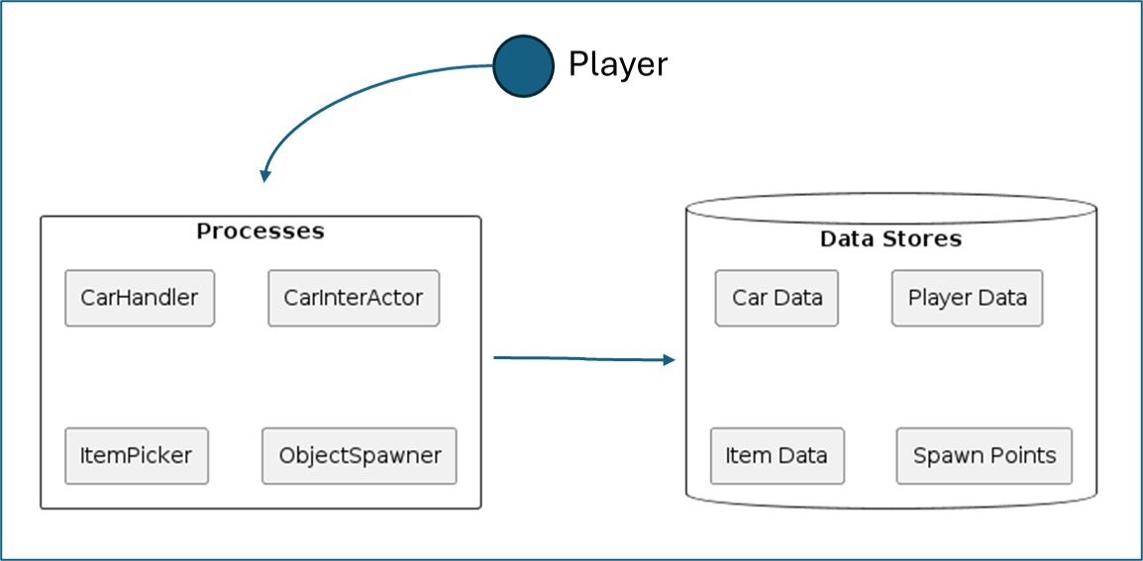

Fig. 3.3.1 DFD Level 0

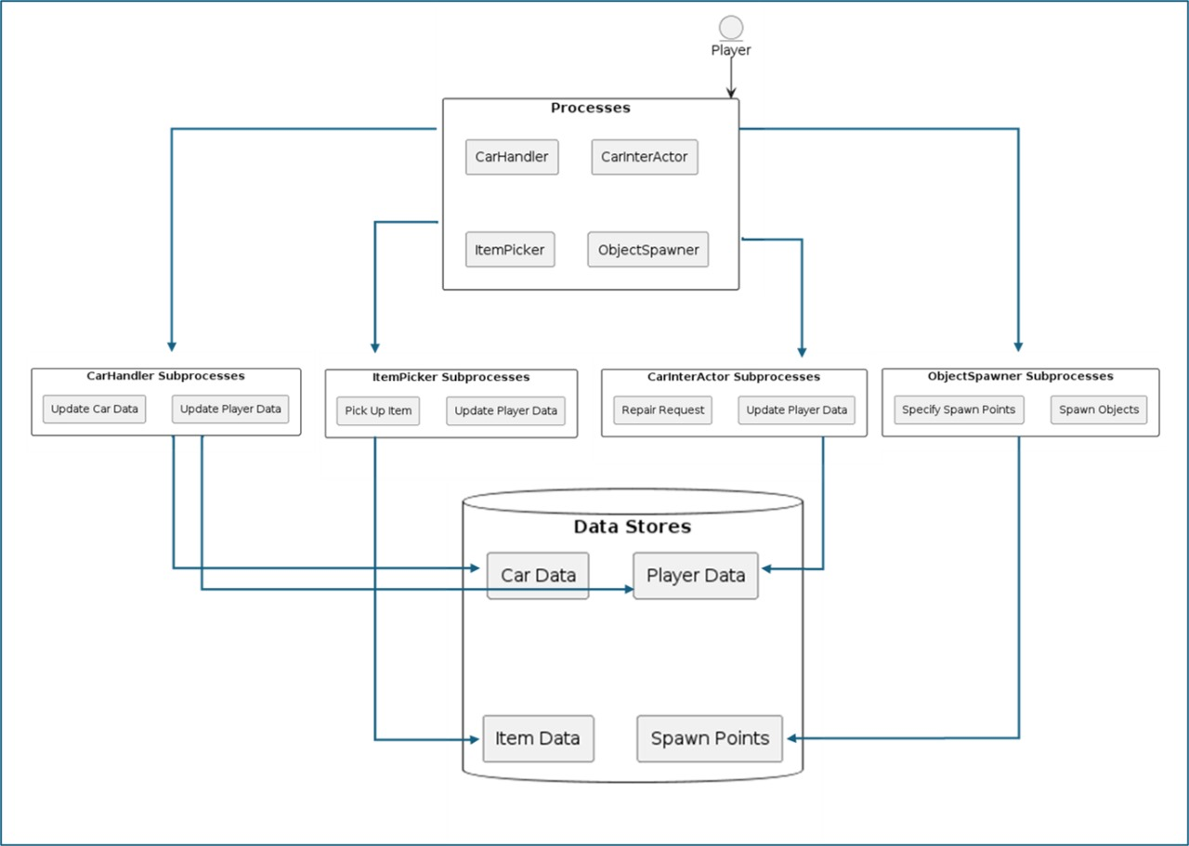

Fig. 3.3.2 DFD Level 1

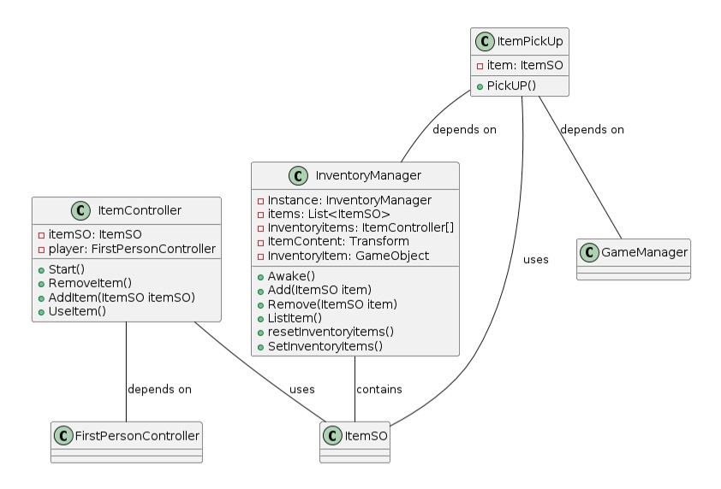

Fig. 3.3.3 Class Diagram

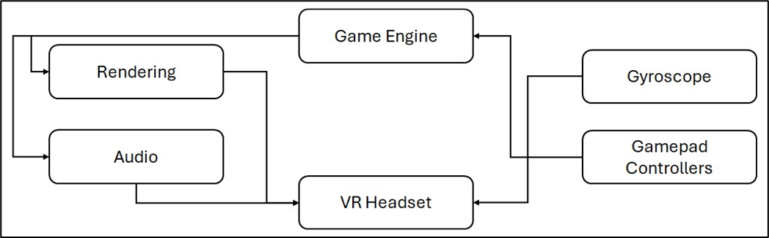

Fig. 3.3.4 Game Architecture

**3.4. Methodology**

The game is a survival horror experience, challenging players to complete all quests to achieve victory.

**1. Object Collection:** Players collect various items essential for completing tasks and progressing.

**2. AI Enemies:** Dynamic AI enemies relentlessly search players, instilling a constant sense of terror.

**3. Google Cardboard SDK:** Integrates VR functionalities on Android devices, including stereoscopic rendering and headtracking.

**4. Gyroscope:** Utilizes sensor data to track players' head movements, enhancing immersion.

**5. Game manager:** The Game Manager is the central hub overseeing game elements like states, UI, input, events, scene changes, logic, and win-loss condition. It synchronizes the elements to ensure a cohesive player experience.

**6.** **Item Spawner:** The algorithm enhances game replayability by randomly spawning items from strategically positioned points across the map.

**7. Audio Management:** Implements 3D spatial audio, ambient music, and eerie sounds for a heightened atmosphere.

**8. User Interface (UI):** VR-friendly UI elements provide essential information and enhance player interaction.

**9. Win Condition:** Victory is achieved by completing all tasks and escaping from pursuing enemies.

**10. Lose Condition:** Failure occurs when players are caught by enemies, leading to game over.

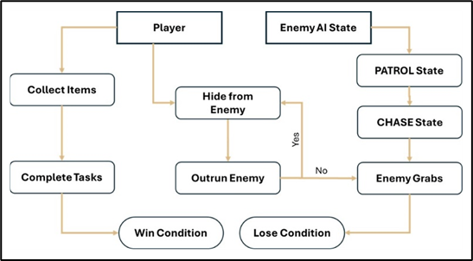  
  
Fig. 3.4.1 Game Mechanism

**3.5. Implementation**

**System Features**

HEAD TRACKING:

Head tracking in the VR horror games on Android will be implemented using Google Cardboard SDK which uses the device's built-in sensors, particularly the gyroscope. These sensors detect the user's head movements, including rotation and tilt. Unity's Android VR integration allows to access this sensor data and update the virtual camera's position and orientation accordingly.

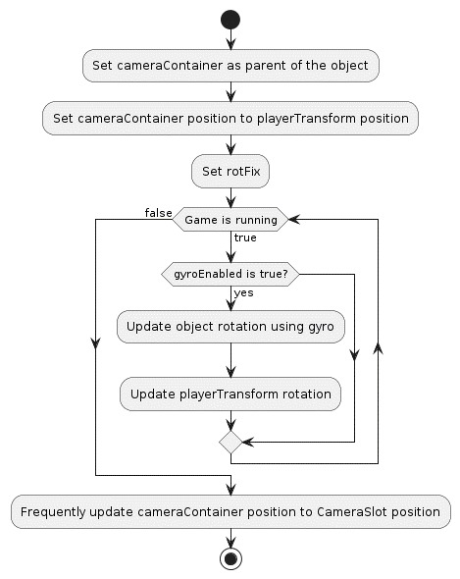

Fig. 3.5.1 Gyroscopic head tracking flowchart

ITEM PICKUP & SPAWNER:

The game uses raycasting for item pickup, enabling players to interact with virtual objects. When the player's VR camera focuses on an object, a ray is cast from the camera's position. If this ray intersects with an interactable object, players can trigger a pickup by pressing a button on their VR controller. Raycasting offers a natural and intuitive interaction method, enhancing immersion and gameplay in the VR horror experience.

The game objects spawn at specified spawn points. The game engine randomly selects spawn points from corresponding lists and instantiates objects based on the specified count, ensuring a varied and engaging gameplay experience. This approach adds randomness and unpredictability to the game world, enhancing player exploration and interaction with objects throughout the game.

TYRES AND OTHER ITEMS SPAWN RANDOMLY AT DESIGNATED POSITIONS

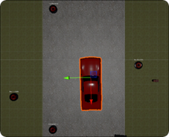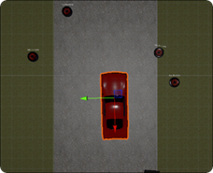

Fig. 3.5.2 Random Item Spawner

ENEMY AI:

The enemy's AI is designed with various states like idle, patrol, chase, grab, and return to patrol. These states dynamically change based on player proximity and randomized movement algorithms, creating suspenseful gameplay. To navigate the terrain, the enemy utilizes a Nav Mesh Agent for smooth movement. The patrol radius gradually reduces over time, adding strategic depth to the enemy's movements and behaviour.

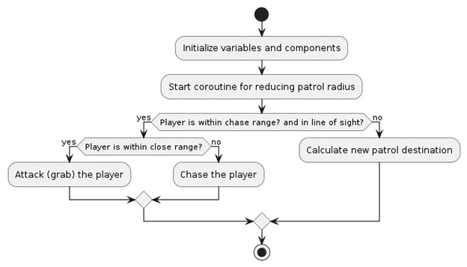

Fig. 3.5.3 Enemy AI Behaviour Flowchart

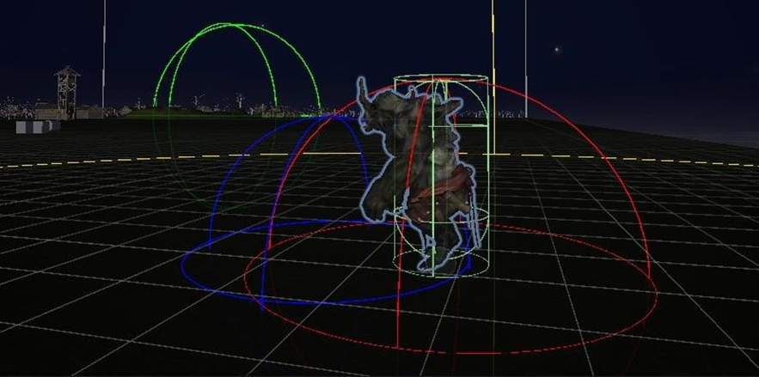

Fig. 3.5.4 Enemy in PATROL State

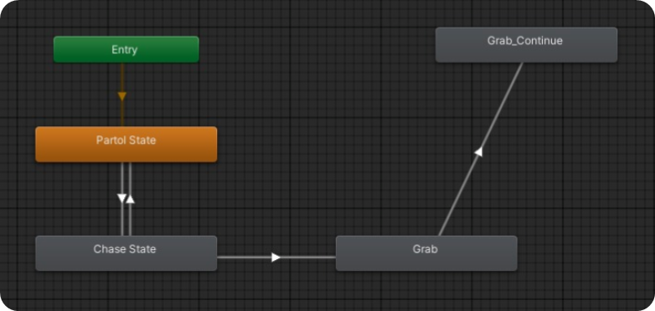

Fig. 3.5.5 Enemy <Animator> Component

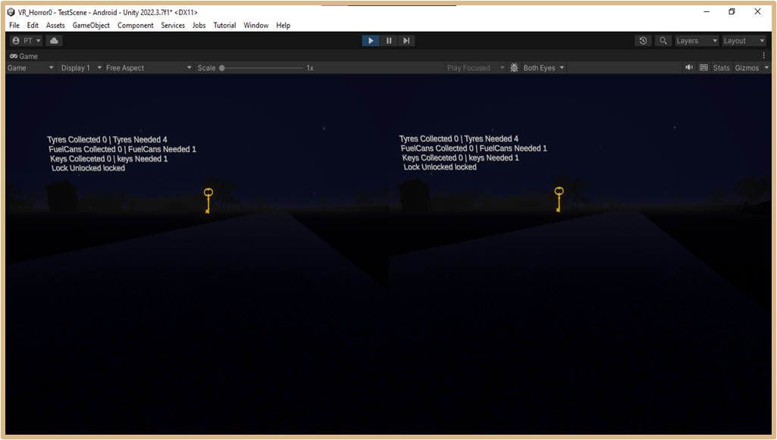

Fig. 3.5.6 Stereoscopic Game Interface

GAME MAP:

Game maps play a crucial role in VR horror games as they provide players with a structured environment to navigate and explore. Well-designed maps not only guide players through the game but also prevent confusion and aimless wandering. In a VR horror game, the map is crafted with diverse topography, offering varied challenges and encounters. It includes strategically placed elements and eerie audio settings, creating an immersive atmosphere that enhances the overall gameplay experience.  
  
  
USER FEEDBACK:

Throughout developments, various testing methods are being employed, including alpha and beta testing, alongside continuous testing among the development team. Initial feedback has positively highlighted the exceptional sound design, contributing significantly to the overall gameplay experience.

**4. Test Cases**

|  |  |  |  |  |
| --- | --- | --- | --- | --- |
| Sr. No. | Name | Input | Output | Type |
| 1 | Environment and Navigation | Gamepad Controller and Gyroscope | The player can navigate through the virtual environment and interact with objects in the environment using VR controllers | Functionality |
| 2 | Gameplay Mechanics | Interactive Objects, Pickable Objects, Enemy, Repairable Objects, Movement | Gameplay mechanics such as puzzle-solving, hiding from enemies. | Functionality |
| 3 | Visual and Audio Effects | Textures, Materials, Lighting, Footsteps Sound, Environmental Sounds, Enemy Audio | Visual effects create the intended atmosphere for a horror experience. | Functionality |
| 4 | User Interface and Controls | Inventory Panel, Captions, Health Bar, Journal | Ensure that the user interface elements are clear and readable in VR. | User  Interface |
| 5 | Compatibility and Integration | Android Devices, Windows | Test compatibility with different input devices to ensure consistent functionality across platforms | Usability Test |

Table No. 4.1 Test Cases

**5. Conclution & Future Scope**

Our VR horror game incorporates a holistic approach to gaming, seamlessly blending immersive environments with advanced technology while catering to the traditional enthusiasm for consuming horror stories. It represents a fusion of past, present, and future elements, presenting VR seamlessly into daily life experiences. Adhering to VR rules and integrating cohesive features, our game sets a new standard for immersive entertainment.

Integration of advanced comfort settings and locomotion techniques, such as teleportation, snap turning, and field-of-view adjustments, to minimize motion sickness symptoms. Implementation of dynamic storytelling elements, nonlinear narratives, and branching paths to enhance player agency and immersion in VR horror environments. Addressing concerns about eye health due to prolonged VR headset use, future VR games may incorporate features such as regular breaks, adjustable display settings, and eye-tracking technology to mitigate potential risks and promote safe VR experiences.

Expanding on multiplayer capabilities, future beginner VR horror games may introduce cooperative or competitive modes for shared immersive experiences. Additionally, offering downloadable content (DLC) can extend gameplay longevity with new levels, characters, or storylines. Optimization efforts will focus on enhancing performance across VR platforms for smoother and more immersive gameplay experiences.

**REFERENCES**

1. Zhang, Ruiqi. "Research on the Progress of VR in Game." Highlights in Science, Engineering and Technology 39 (2023): 103-110.
2. Bian, Shijie. "Research on the Application of VR in Games." Highlights in Science, Engineering and Technology 39 (2023): 389-394.
3. Lin, Tammy Jin-Hsuan. "Virtual Reality Horror Games and Fear in Gaming." In Oxford Research Encyclopedia of Communication. 2023.
4. de Lima, Edirlei Soares, Bruno MC Silva, and Gabriel Teixeira Galam. "Adaptive virtual reality horror games based on Machine learning and player modeling." Entertainment Computing 43 (2022): 100515.
5. Zhang, Ziwen. "Analysis of the design aesthetics and player emotions of horror games: Take ‘Little Nightmares’ as a case." (2022).

1. Årnell, Tobias, and Nikola Stojanovic. "Horror game design–what instills fear in the player?: A study on the effects of horror game design theories and level design patterns on player behaviour in a horror environment." (2020).
2. Lin, Jih-Hsuan Tammy, Dai-Yun Wu, and Chen-Chao Tao. "So scary, yet so fun: The role of self-efficacy in enjoyment of a virtual reality horror game." New Media & Society 20, no. 9 (2018): 3223-3242.
3. Ntokos, Konstantinos. "Level of fear”: Analysis of fear spectrum into a tool to support horror game design for immersion and fear." An International Journal (CGDEIJ) 1, no. 33-43 (2018).

**Publications by the Candidates**

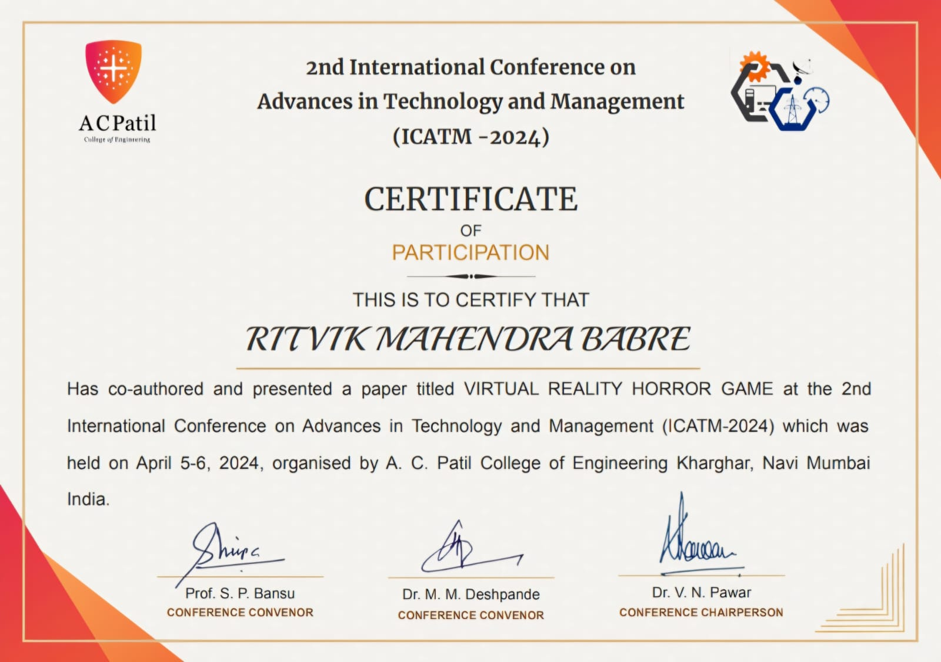

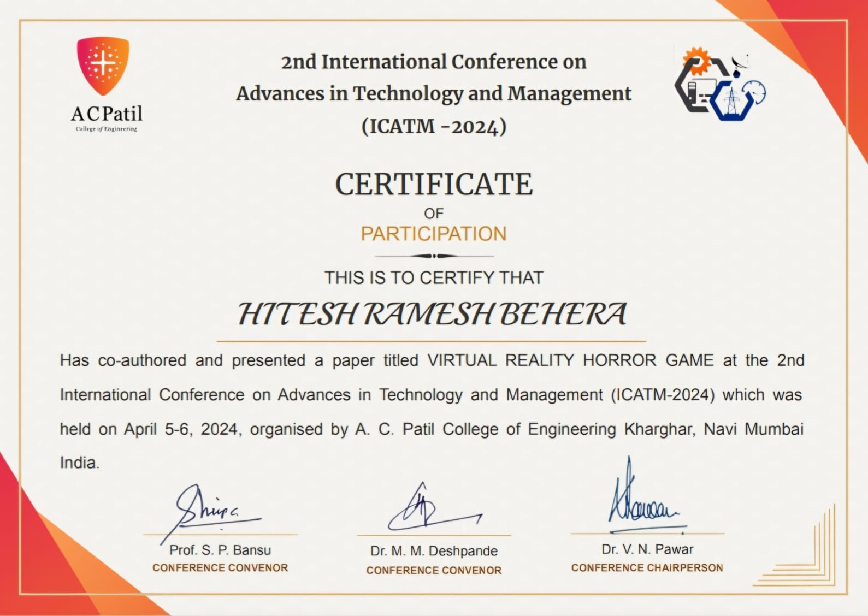

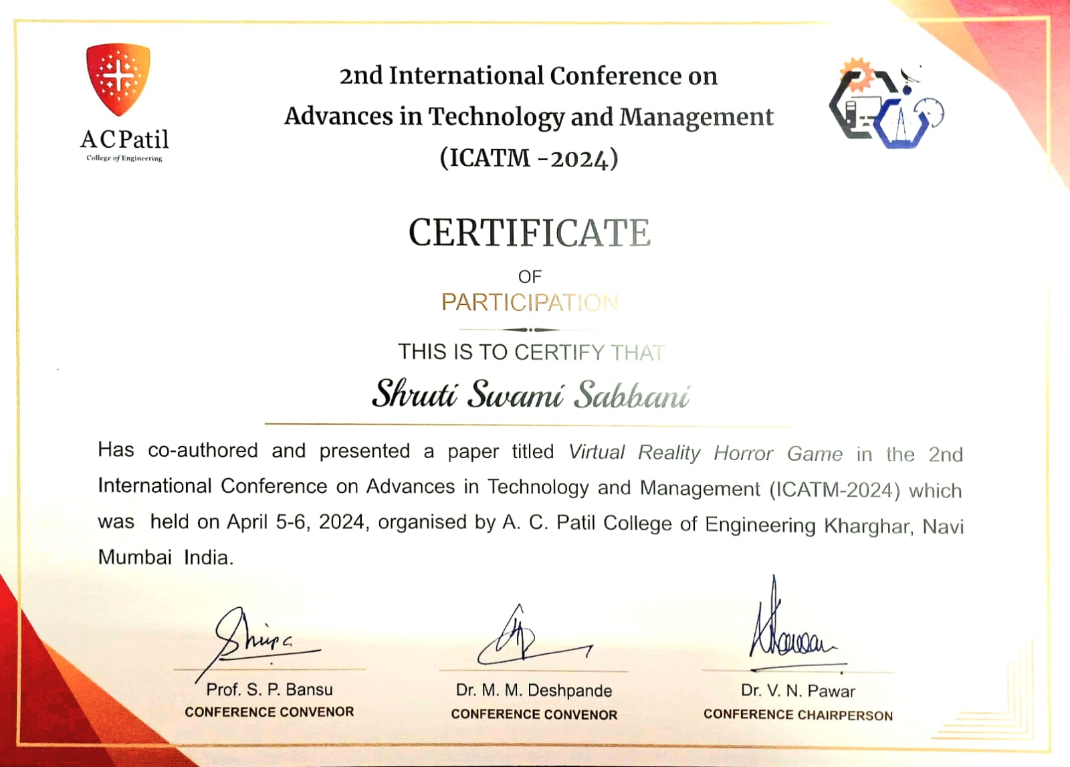

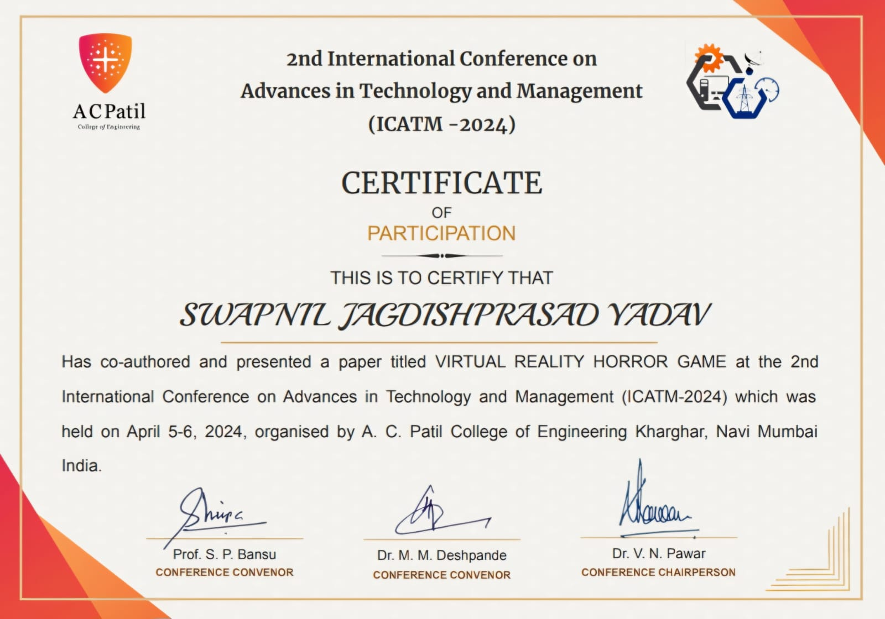

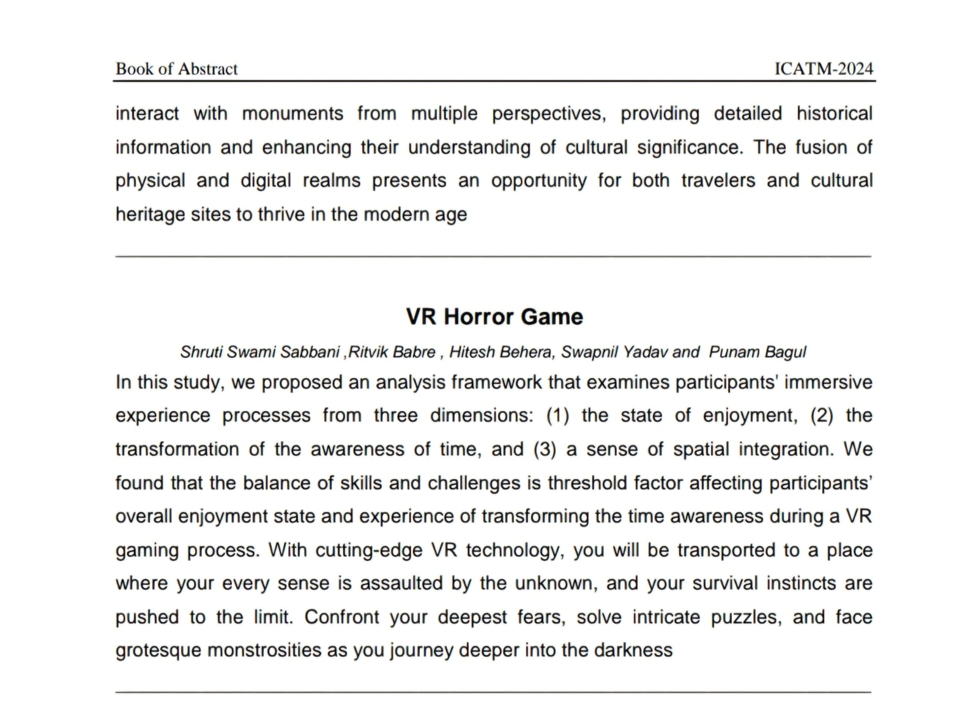

<https://icatm.in/>



  
  
  


